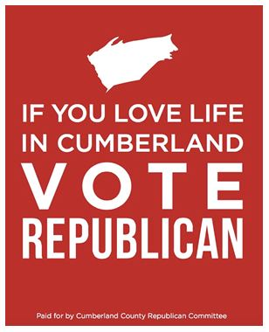
August 12, 2019

Dear Fellow Upper Mifflin Township Republican,

Kingsley Blasco and I wanted to introduce ourselves to you. Kingsley and I are the Republican Precinct Committee Persons for Upper Mifflin Township. As your Precinct Committee Persons, we are to represent the registered Republican voters in the Township to the Cumberland County Republican Committee (CCRC) and represent the Republican Committee of Cumberland County to the Republican voters. We are to be a channel between the County GOP Committee and you.

Kingsley is owner of Blasco Insurance, was a Big Spring School District school board member for several years and is on the November ballot to be a township supervisor. I am a homemaker and have lived in the township for almost 19 years. I am the current Chairwoman of the Western Cumberland County Republican Club (WCCRC) www.cumberlandrepublican.club

Both Kingsley and I are wanting to build a closer relationship with the Republican voters in the Township and to encourage connection with the CCRC and the WCCRC. We wanted to share with you the website and Facebook pages of the CCRC. They are www.gopccpa.org and https://www.facebook.com/gopccpa . One of our upcoming events is the inaugural Liberty BBQ to be held on September 7th in Penn Township. You will find an invitation enclosed. Additionally, the CCRC holds an Annual Fall Dinner. This year it will be on Tuesday, October 8 at the Camp Hill Radisson. The special keynote will be journalist, Sharyl Attkisson. Tickets and prices will be available soon on the Committee’s website. Both these events are a nice time to be with like-minded individuals.

Please do not hesitate to reach out to Kingsley or myself.

Sincerely,

Theresa Myers  717-423-6907 (home)  Email theresa.gop@gmail.com | Kingsley Blasco  717-776-7138  Lazybend@earthlink.net

